WPL LAB 5 HW
name: Abhinav Singh Bhagtana
reg no: 230905225
roll no: A-029

Q1.Develop a simple web page to reproduce the given Captcha. Upon match, suitable
message has to be displayed. If there is a mismatch for more than 3 times, TextBox
has to be disabled.
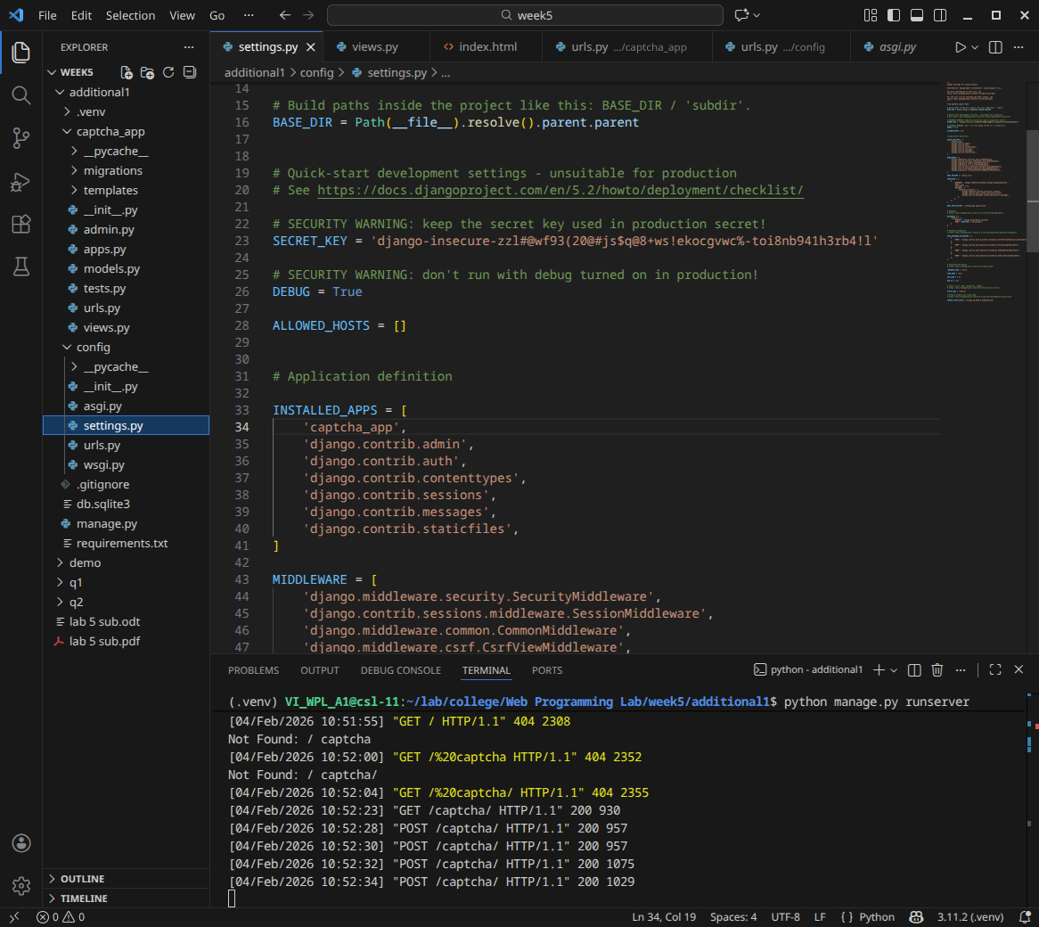
Urls.py
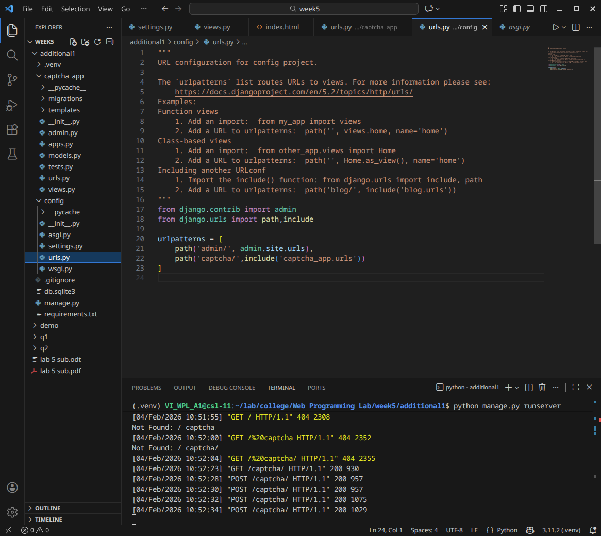
views.py
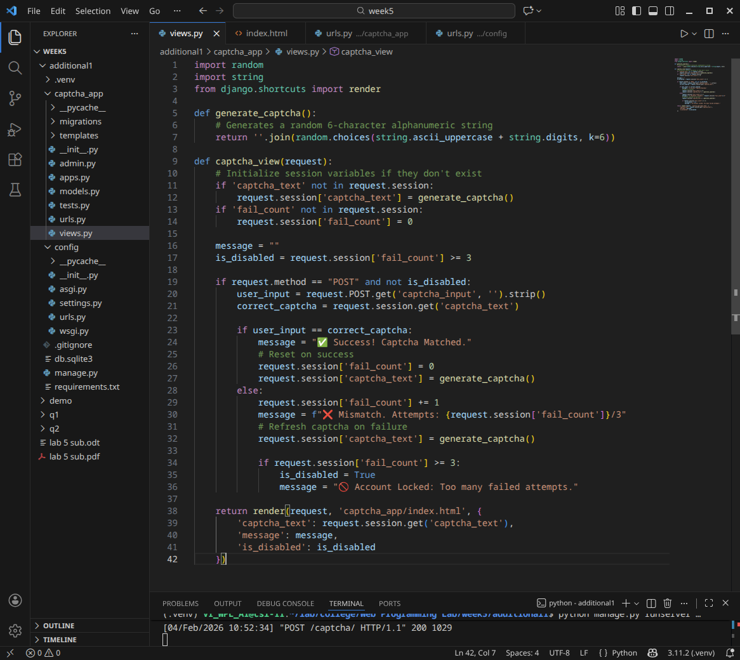
urls.py
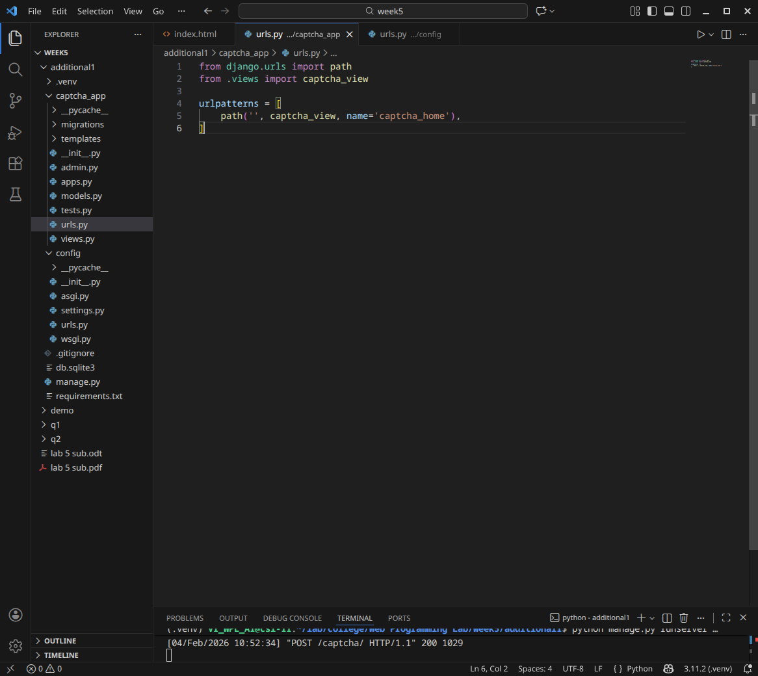
index.html
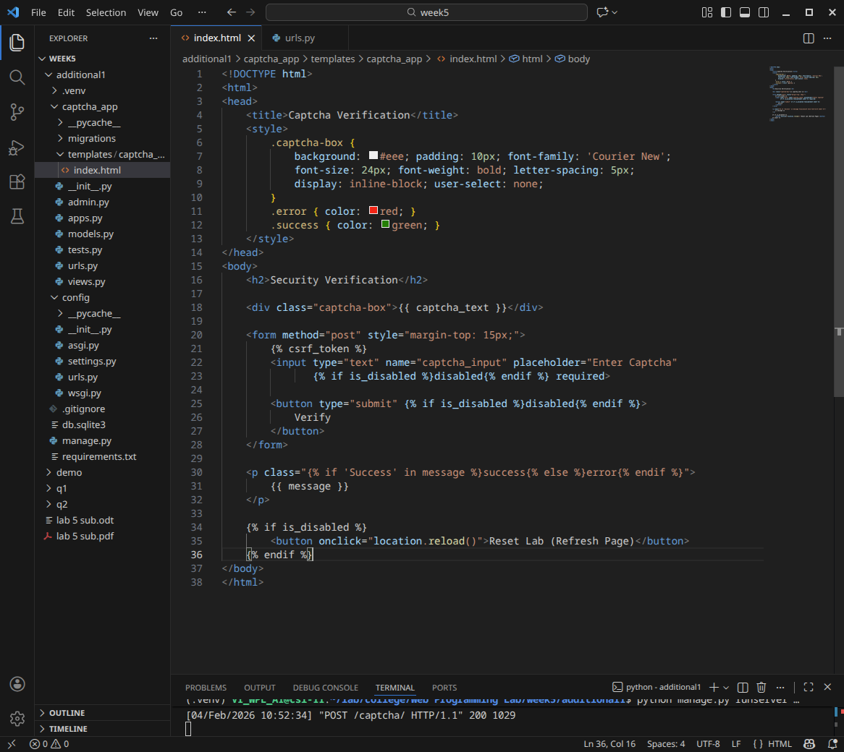
website
